# **Erum Sikander Sunday 2 to 5 pm**

# **Hackathon - 3 Day 7**

**Step 1: I Have Completed Payment Method Integration:**

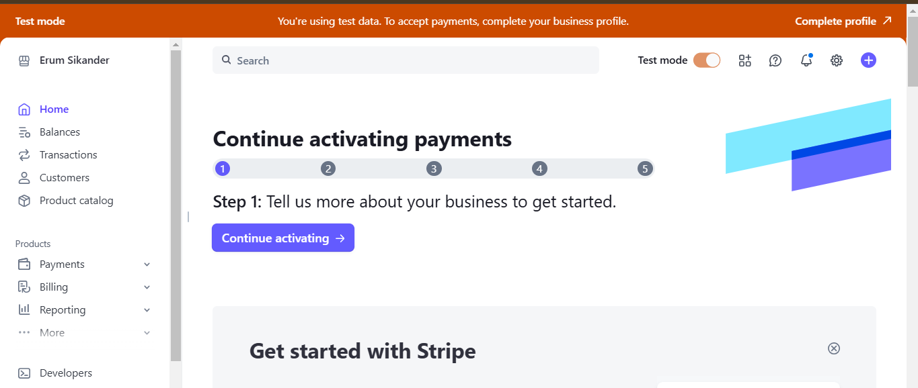

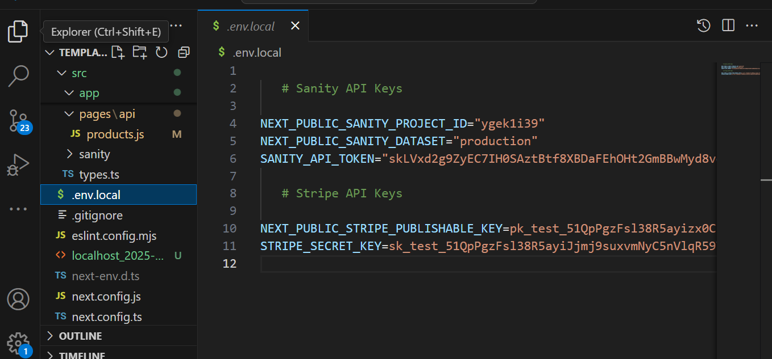

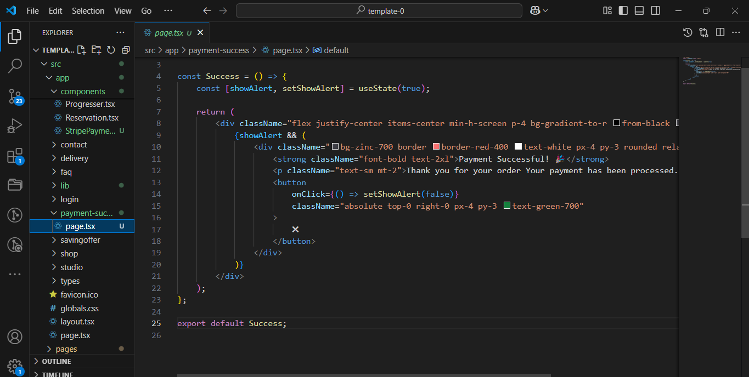

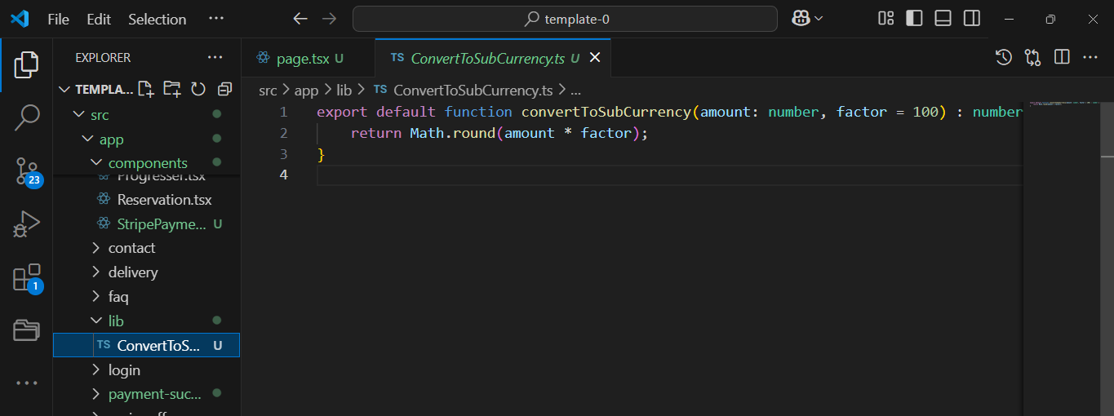

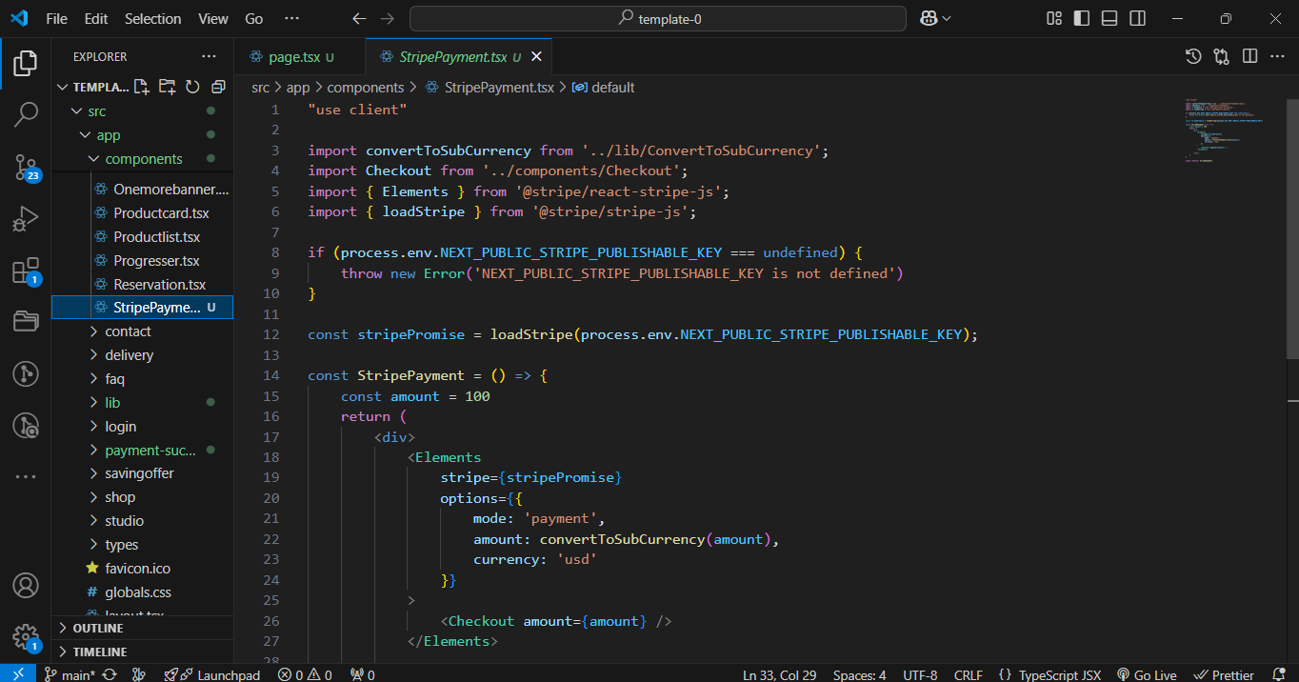

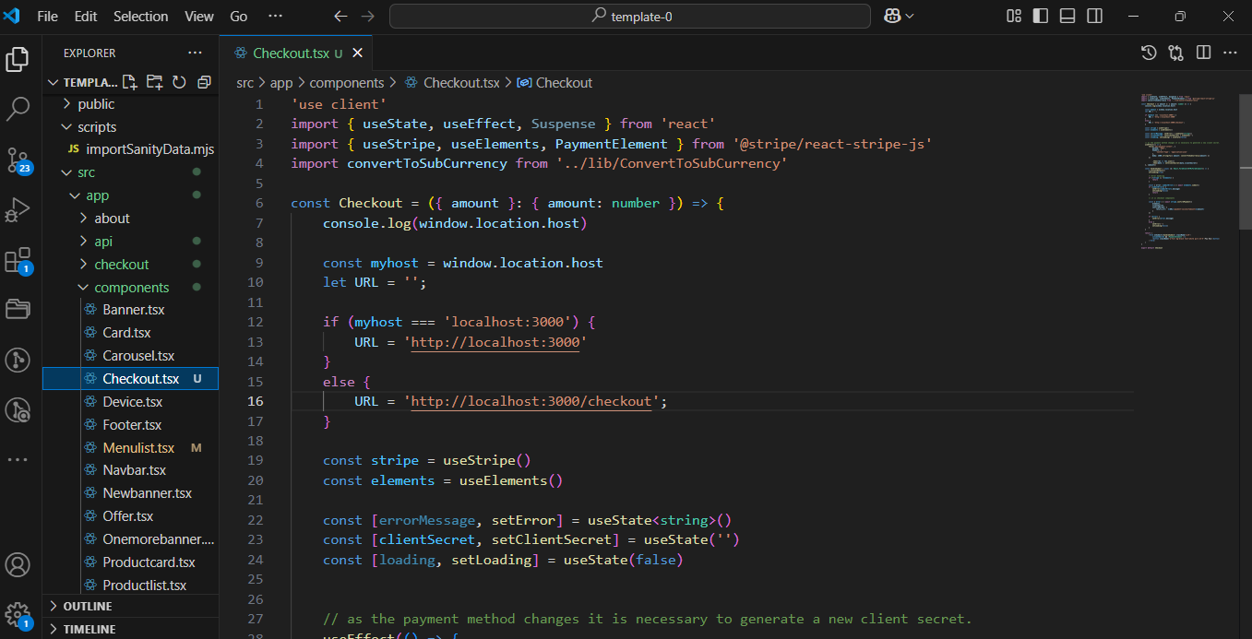

Step 2:

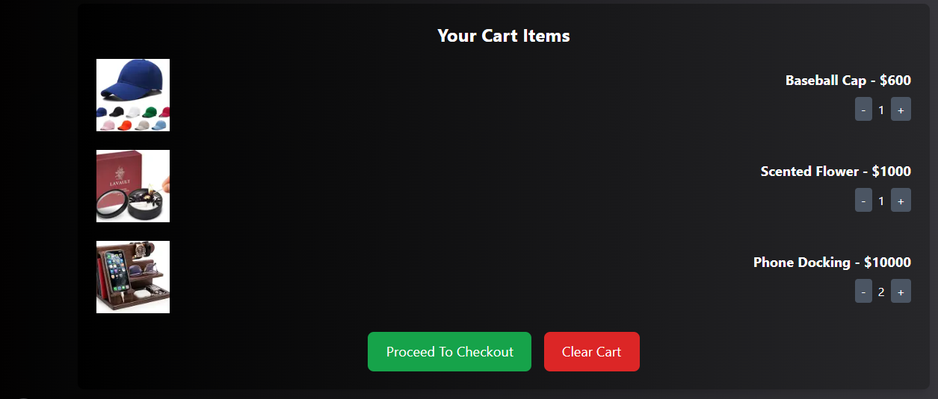

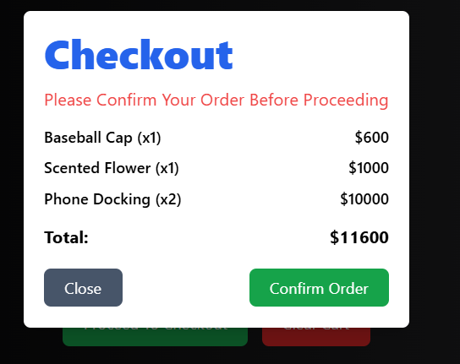

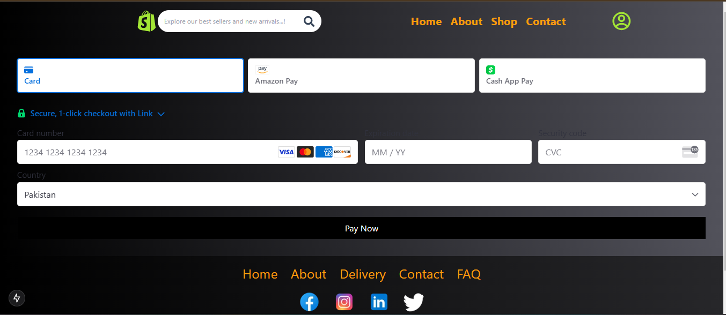–

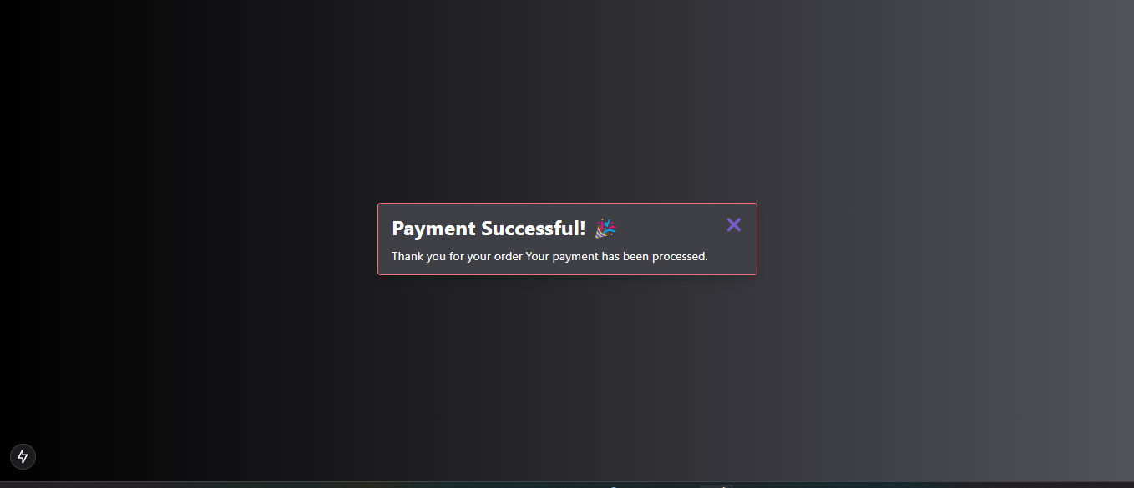

Building this **e-commerce website** was a big challenge for me. At first, I didn’t know where to start, and everything felt confusing. But once I began, I faced many errors and obstacles along the way. With hard work, sleepless nights, and continuous effort, I managed to fix everything and finally complete my website. I’m deeply grateful to **all my teachers**, especially **Sir Ameen Alam**, **Sir Ali Jawad**, **Miss Nida**, **Sir Sami**, and all the faculty members. Thank you for giving me the chance to learn and for guiding me through this journey. This project taught me so much, and because of your support, **I can now proudly call myself a Frontend Developer** my name is **Erum Sikander**, a senior student of the **Sunday 2 to 5 PM class**. Thank you for everything!

**Your obedient student,**

**Erum Sikander**

**Sunday 2 to 5 pm (Senior Student)**

**Thank You…!**